Investigation of whisper.cpp: Saving Speech to a .txt File
Target: whisper-cli.exe (whisper.cpp, Windows 64-bit Release build)
Feature studied: saving recognized speech into a .txt file
Tools: REA MCP tools with the Ghidra 12.1.4 provider

1. Introduction
whisper.cpp is an open-source C++ program that turns speech into text. In this work I studied the compiled program whisper-cli.exe. I focused on one feature: saving the recognized speech into a .txt file.
I used REA with Ghidra to look inside the program. Every fact below names the REA tool that found it. The program has no original function names, so Ghidra’s default names are used (for example FUN_140006760).

2. REA tools used
- open_binary: opened whisper-cli.exe.
- binary_overview: showed the sections, 912 functions and 630 strings (ev_752b117d30fe).
- search_strings: found the strings about .txt output (ev_283cd174bce3, ev_4108ac7d4064, ev_da17d067ed10).
- xrefs: showed which code uses each string (ev_87b7ace1e17c, ev_a60ee526fe44, ev_5b4d81c3f552, ev_3bc49c642da9).
- analyze_function: gave a summary of FUN_140006760 (ev_b84d1b44c92d).
- procedure_pseudo_code: showed decompiled code of FUN_140010c20 and FUN_1400095a0 (ev_7c8f4ca1411b, ev_fa6d2ac54a98).
- inspect_pe_imports: listed the DLLs and functions the program uses (ev_44e8f1461012).

3. Technology stack
- File type: 64-bit Windows program (PE32+, x86-64), 479,744 bytes. (binary_overview, inspect_pe_imports)
- Memory layout: image base 0x140000000. The code section (.text) is 386,560 bytes. (binary_overview)
- Language: C++ built with the Microsoft Visual C++ runtime. It uses MSVCP140.dll, VCRUNTIME140.dll and the Windows Universal CRT. (inspect_pe_imports)
- Speech engine: whisper.dll. The program imports 37 functions from it, such as whisper_init_from_file_with_params, whisper_full_parallel, whisper_full_n_segments and whisper_full_get_segment_text. (inspect_pe_imports)
- Math library: ggml.dll. The program imports one function from it, ggml_backend_load_all. (inspect_pe_imports)
- Windows functions: CreateFileA, ReadFile, CloseHandle, SetConsoleOutputCP, LoadLibraryA, GetProcAddress. (inspect_pe_imports)
- File writing: C++ std::basic_ofstream plus C functions such as fopen_s, fwrite, fclose and fflush. (inspect_pe_imports)
- Analysis tool: Ghidra 12.1.4 through the REA provider “rea-workflow”. (binary_overview)

4. Main features of the program

These features were identified using search_strings and procedure_pseudo_code.
- Loads an AI model from a file.
- Reads audio files for speech recognition.
- Can convert speech into text or translate it.
- Supports different languages.
- Provides speaker separation options.
- Saves results in different formats, such as .txt, .vtt, .srt, .csv, and .json.
- Can also display the results on the screen.

5. The selected feature: saving to .txt

5.1 Evidence from strings
Address | Text | What it means
0x140060db8 | “-otxt” | Short command option. Used at 0x14000e351 (argument parsing).
0x140060dc0 | “--output-txt” | Long form of the same option.
0x140061a60 | “-otxt, --output-txt ... output result in a text file” | Help text.
0x140063388 | “output_txt” | Label used at 0x140012d4a inside the main function.
0x140062e98 | “%s: failed to open ‘%s’ for writing” | Error message, used at 0x14000699a in FUN_140006760.
0x140062ec0 | “%s: saving output to ‘%s’” | Success message, used at 0x1400069d7 in FUN_140006760.
0x140063430 | “.score.txt” | A different file for confidence scores. It is not the main transcript.
(Tools: search_strings and xrefs)

5.2 Functions involved
1. FUN_140010c20 – Main Function
- Controls the main program.
- Reads command-line options.
- Loads the AI model.
- Processes audio using whisper_full_parallel.
- Calls other functions to save output.
2. FUN_140006760 – File Opener
- Creates and opens the output file.
- Adds the file extension, such as .txt.
- Shows a success message if the file opens.
- Shows an error message if it fails.
3. FUN_1400095a0 – Text Writer
- Gets the recognized speech segments.
- Reads the text of each segment.
- Writes the text into the .txt file.
- Adds a new line after each segment.
4. Whisper DLL Functions
- whisper_full_n_segments: Gets the total number of speech segments.
- whisper_full_get_segment_text: Gets the text of a segment.
- whisper_full_get_segment_t0/t1: Gets the start and end time of a segment.

5.3 Input and output
- Input to the writer: Recognized speech data, an already-open file, settings, and audio channel information.
- Input to the file opener: File name, .txt extension, and the label output_txt.
- Output: A .txt file containing recognized speech, with each segment on a separate line.
- Messages: Success or error messages are displayed in stderr.
- Return value: The file opener returns true if the file opens successfully.

6. Workflow
- Audio processing: whisper_full_parallel converts audio into recognized speech. If it fails, an error is printed.
- Check option: Main checks whether -otxt is enabled.
- Open file: FUN_140006760 creates a file named audio-name.txt.
- Check file: If successful, it prints saving output to. Otherwise, it prints an error.
- Write text: FUN_1400095a0 writes the recognized speech into the file, one segment per line.
- Speaker labels: If diarization is enabled and there are two audio channels, a speaker prefix may be added. (Inferred from analysis.)
- Close file: The file closes automatically, and the program continues to the next output format or audio file.

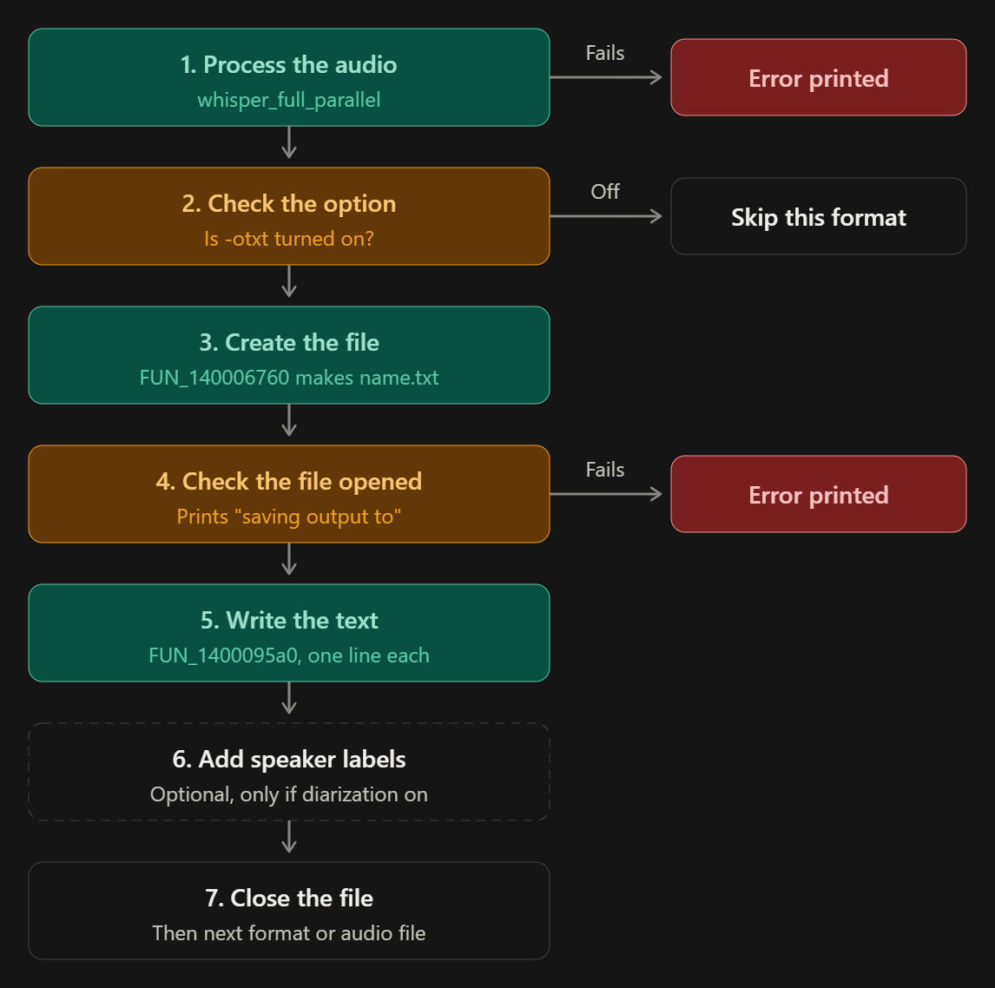

Evidences:
- Opened whisper-cli.exe in Ghidra
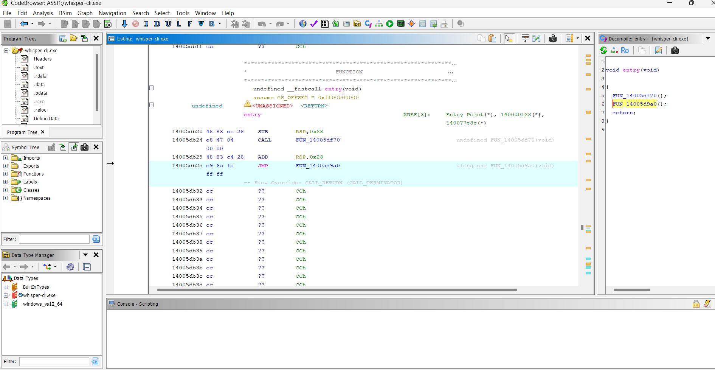

- Program Section:

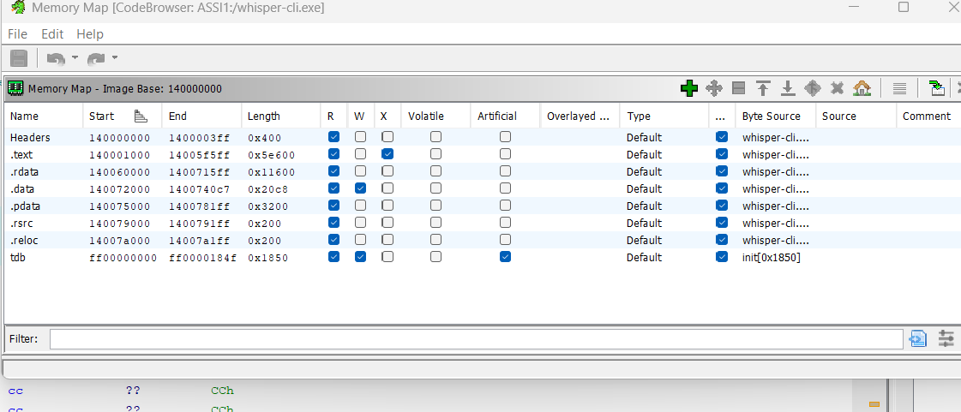
- Found the strings linked to .txt saving:
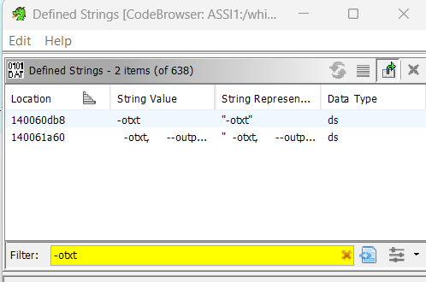
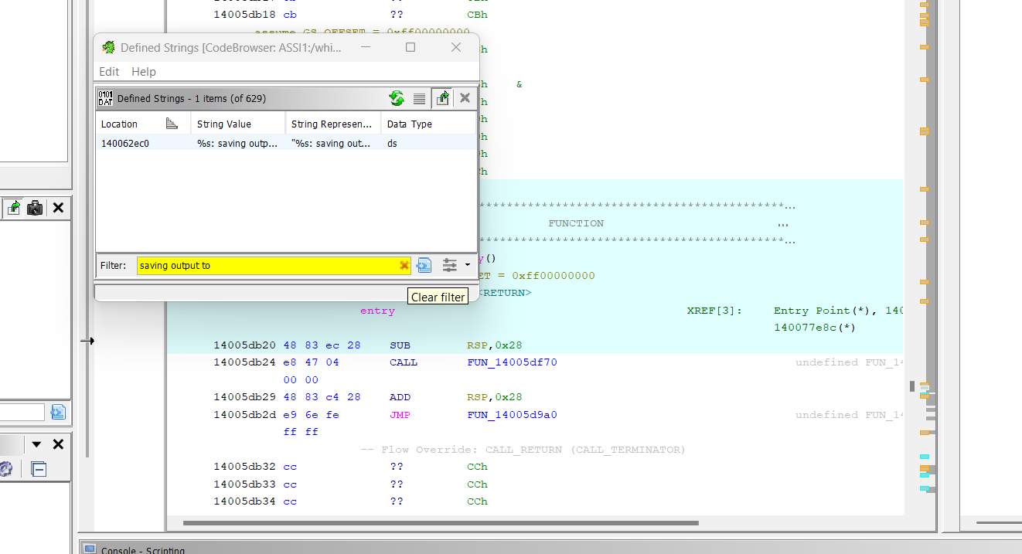

- FUN_140006760: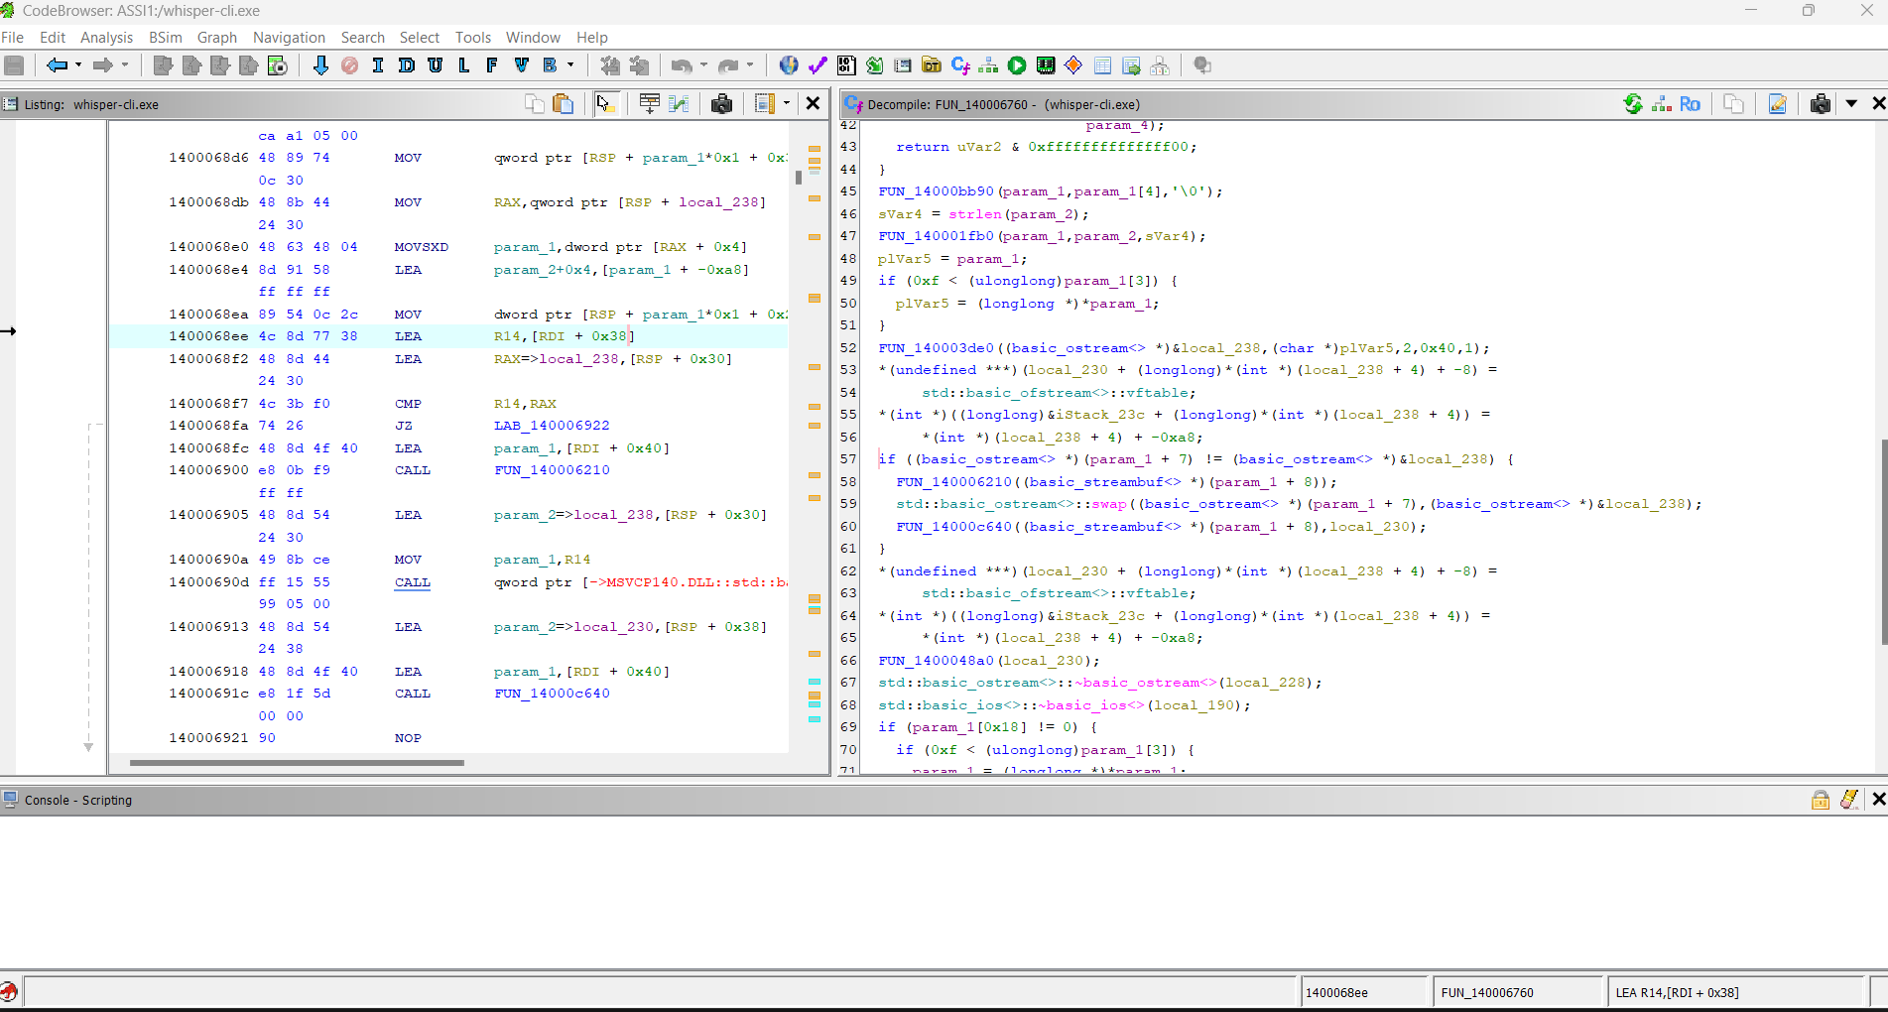
- FUN_1400095a0 (the .txt writer):
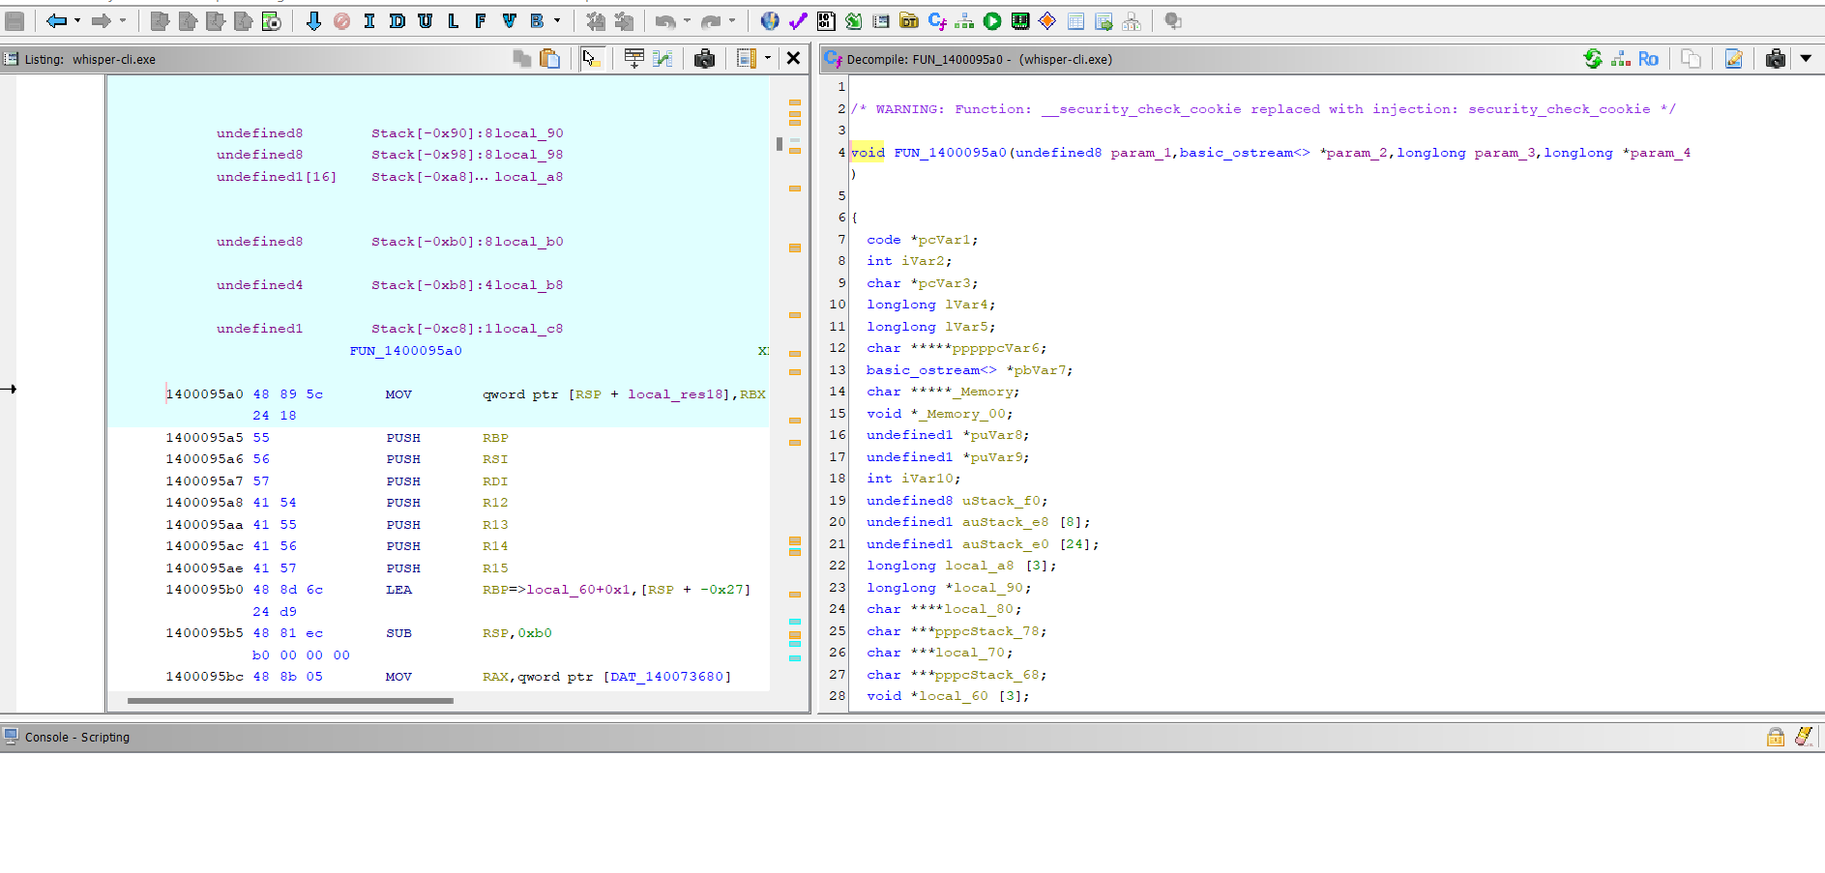
- FUN_140006760 – Listing and Decompiler: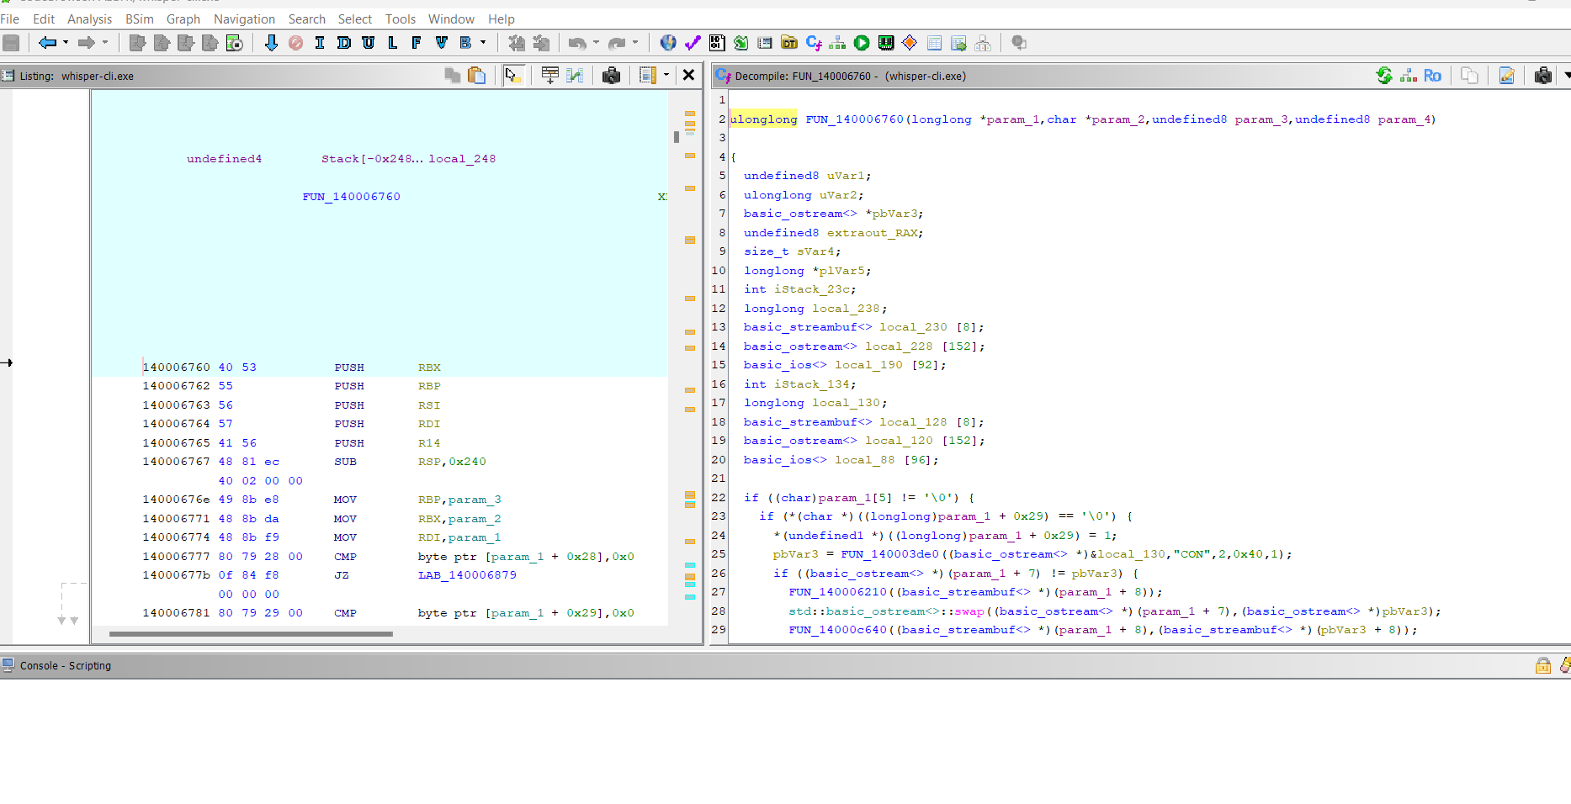
- FUN_1400095a0 – Text writer

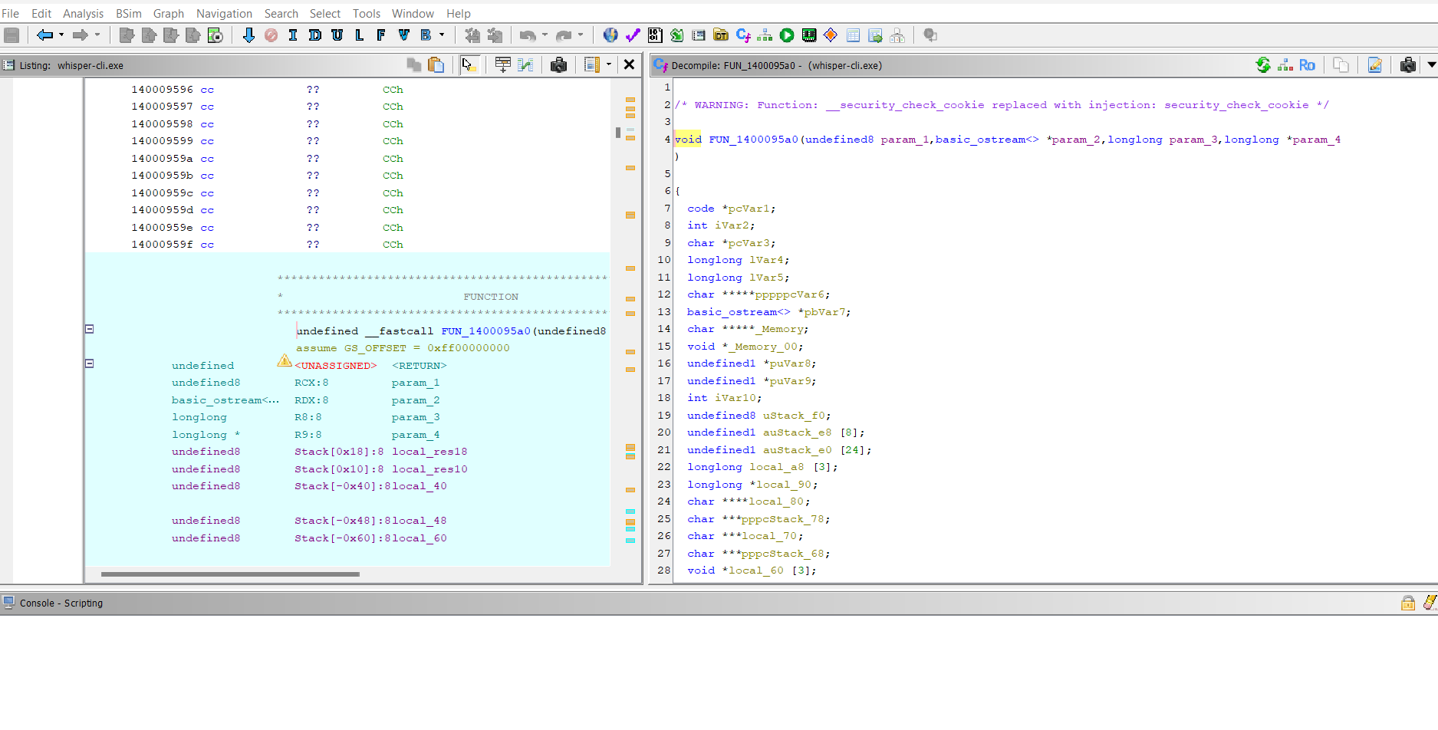
- References / Xrefs – Find where output_txt is used:

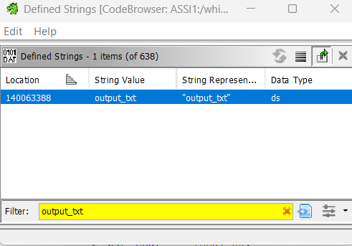

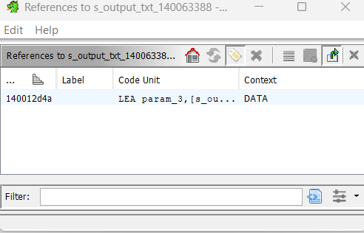

AI Tools and External Resources
- REA GitHub repository: https://github.com/morluto/rea
- Ghidra 12.1.4 for binary analysis.
- Claude Code / ChatGPT for assistance in understanding reverse-engineering results and organizing the report.

